Community Consultation Report
Proposed Development and Ongoing Project – Initial Resident Feedback

1. Introduction
This report presents the findings from the first stage of community consultation undertaken to gather residents’ views on the proposed development and associated ongoing project. The purpose of this initial consultation was to listen to local perspectives, identify key concerns and aspirations, and provide the council with an early understanding of how best to support the community as proposals progress.
A total of 67 responses were received through an open-ended consultation. As this was an early engagement exercise, the feedback reflects initial sentiment rather than views on detailed or finalised proposals.

2. Overall Sentiment
The responses demonstrate a wide range of views, from strong opposition to clear support, with many residents expressing mixed or conditional opinions. Key themes include concerns about traffic and environmental impacts, strong attachment to landscape and heritage, cautious optimism about economic benefits, and the importance of trust and transparency.

3. Quantitative Overview of Responses
Although responses were open-ended, comments were grouped into themes to provide an indicative quantitative overview. Many responses referenced more than one theme.

3.1 Themed Analysis
Traffic, access and disruption (54%), environmental and wildlife concerns (37%), landscape and heritage impacts (21%), economic benefits (16%), general opposition (12%) and supportive views (12%).
Figure 1: Key themes identified in consultation responses.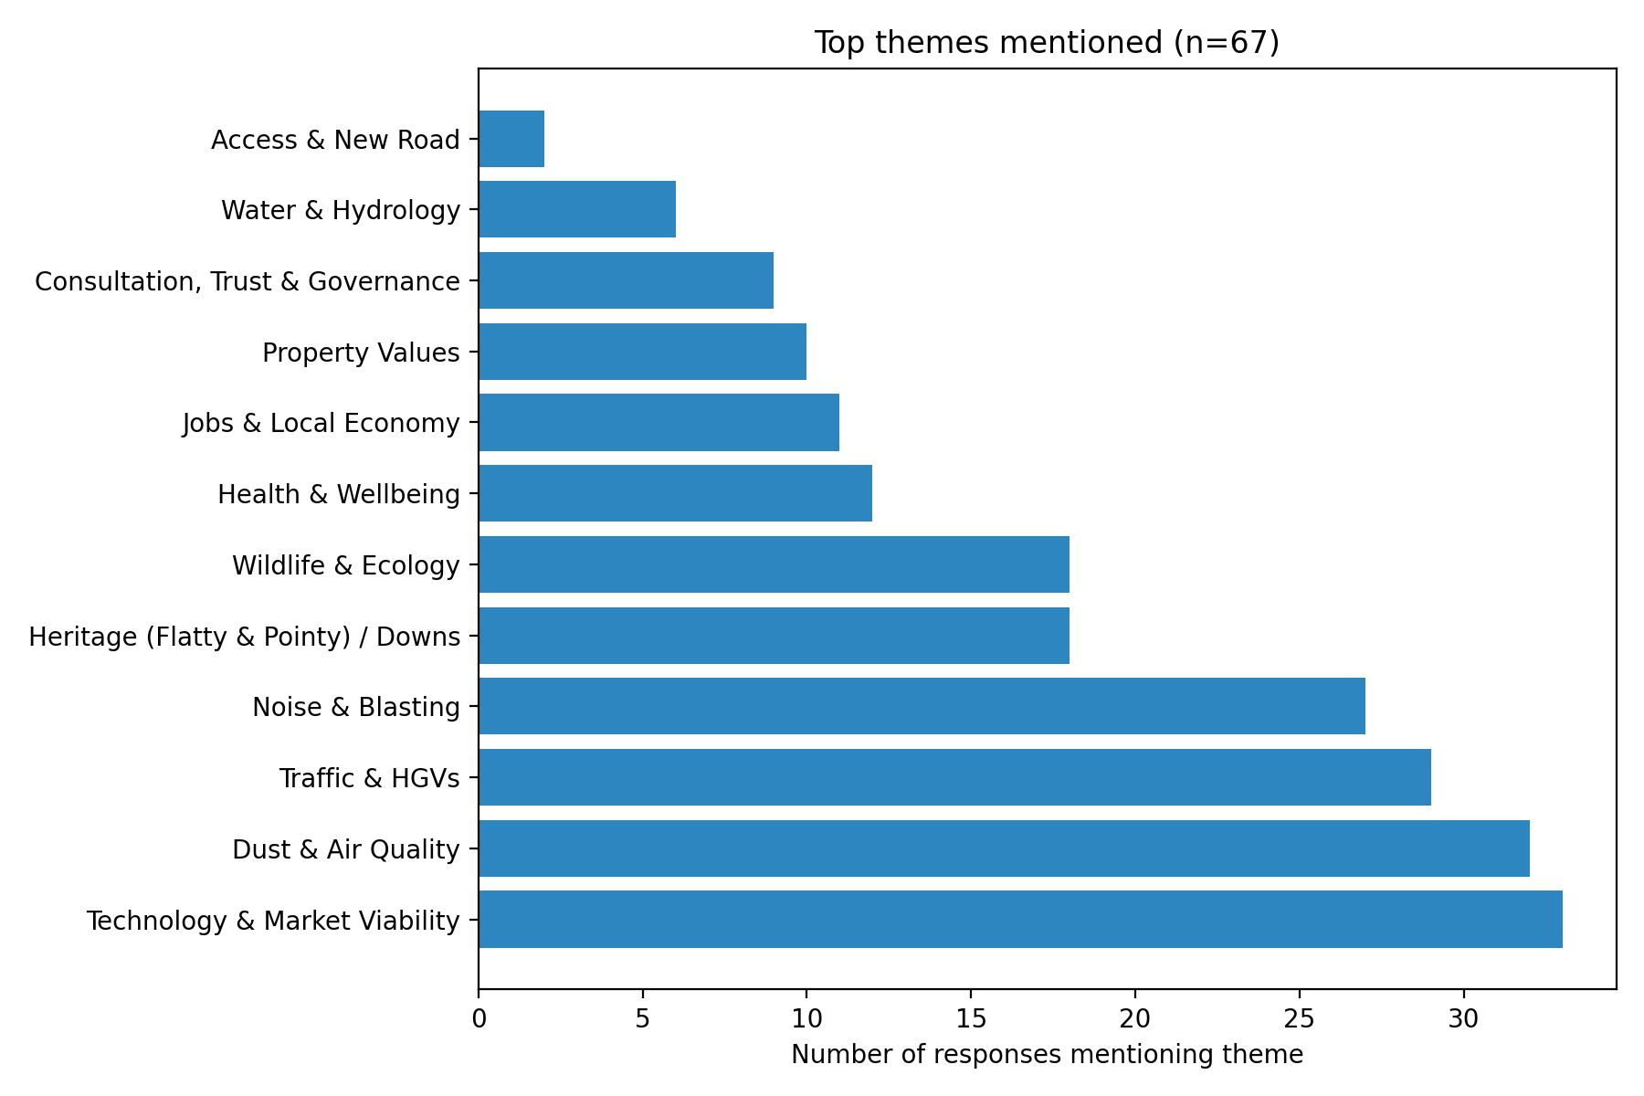

3.2 Timeline of Responses
Responses peaked shortly after launch, with smaller peaks later in the consultation period and a tapering toward closure.
Figure 2: Timeline of consultation responses by date.
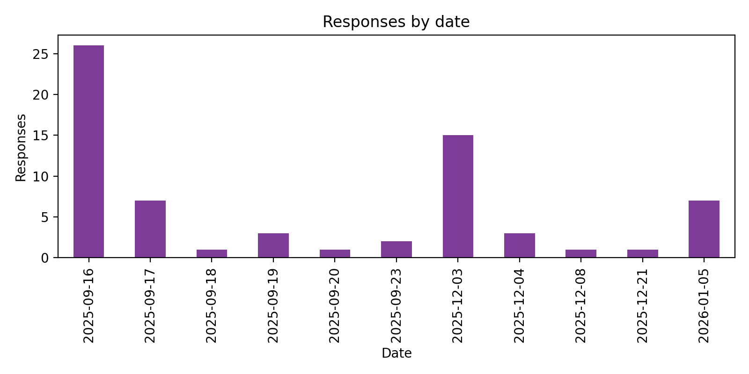

4. Key Themes from Qualitative Feedback
Residents raised consistent issues relating to traffic disruption, environmental protection, landscape and heritage, economic opportunity, and trust in communication.

5. Key Messages for the Council
Traffic and environmental impacts are priority concerns. Residents value heritage and rural character. There is conditional support where benefits are clear. Ongoing transparent engagement is essential.

6. Conclusion and Next Steps
This first-stage consultation provides valuable insight into resident priorities. Continued engagement will be required as proposals develop, ensuring feedback informs future decision-making.

